**Elementary Woodwind, Brass, and Percussion Audition Materials**

**Auditions for Fall 2025:** All students (continuing and new) must audition for an ensemble. Students must submit audition video via Large Ensembles page on Preparatory website.

**Audition materials can be submitted immediately.**

**Submission deadline is June 15th.**

**Video Requirements:**

* You may submit multiple videos.
* Your video must be filmed in a single take without editing and without piano accompaniment.
* Introduce yourself at the start of your video (Full Name, Instrument)
* Performance backgrounds should be of a neutral setting. Be sure that you and your entire instrument are in the frame and properly lit so that you and the instrument are clearly visible.
* Try to achieve the best sound quality you can by finding a quiet time of day to record or a place that has minimal noise disruptions.
* Recording camera or phone should be placed on a stable surface to minimize shake and jitter.
* Please review all recordings so that your video and audio are the quality you want.
* All recordings must be uploaded as part of this application submission.
* Videos can be accepted as hyperlinks OR in the following video formats: .3g2, .3gp, .avi, .m2v,

.m4v, .mkv, .mov, .mpeg, .mpg, .mp4, .mxf, .webm, .wmv o *Be sure that your video is not set to private so that it may be viewed by conductors.*

# Winds/Brass (and Bells)

(Flute, Oboe, Clarinet, Saxophone, French Horn, Trumpet, Trombone, Baritone, Euphonium, Tuba, and Bells)

* B-flat Concert Scale with Tonic and Dominant arpeggio (see following pages)
* B-flat Scale Etude (see following pages)
* A short solo of the student’s choice that demonstrates their current level of ability.

# Percussion

* Students MUST complete the Snare Drum excerpts on the following pages (Snare Drum Excerpt #1 and #2) – see following pages.
* A short solo of the student’s choice that demonstrates their current level of ability on Snare Drum.
* *Students MAY choose to also demonstrate mallet percussion by playing the B-flat Concert Scale with Tonic and Dominant Arpeggio (see following pages) AND the B-flat Concert Scale Etude. This is not mandatory, to audition for percussion, but is highly recommended.*

# B-flat Concert Scale (and Tonic/Dominant arpeggio)

Play the highlighted portion of the musical example below. Be sure to follow the rhythm and articulate/tongue each note.

## FLUTE / OBOE / BELLS CLARINET/ TRUMPET

## ALTO SAXOPHONE

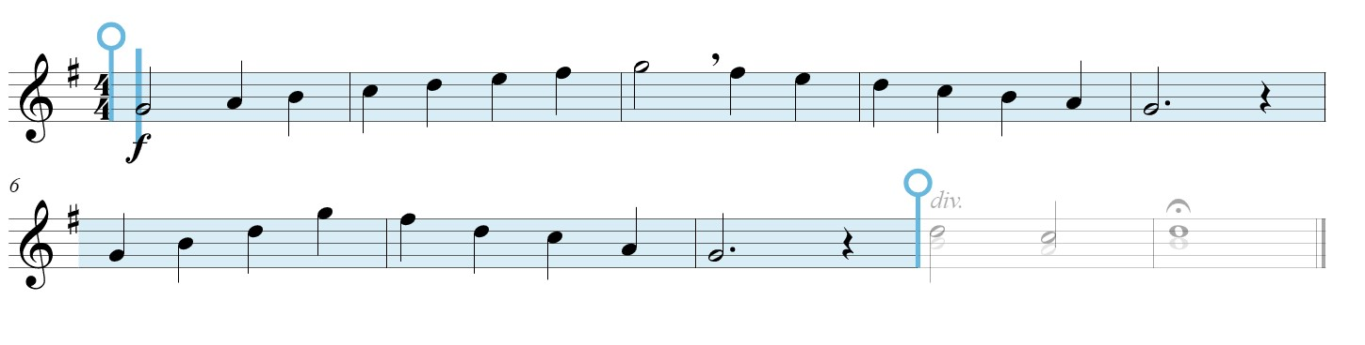

## TENOR SAXOPHONE

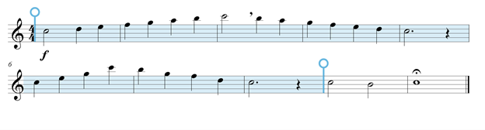

## FRENCH HORN

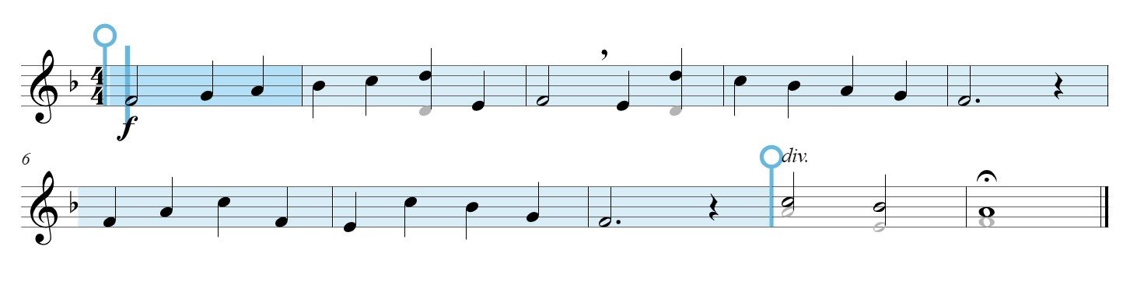

## TROMBONE / BARITONE / EUPHONIUM

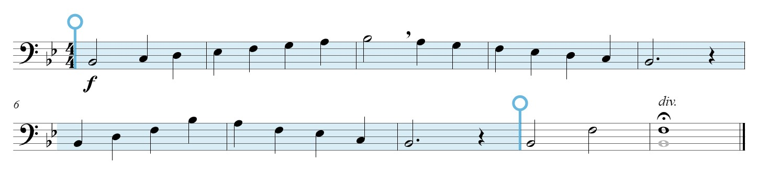

## TUBA

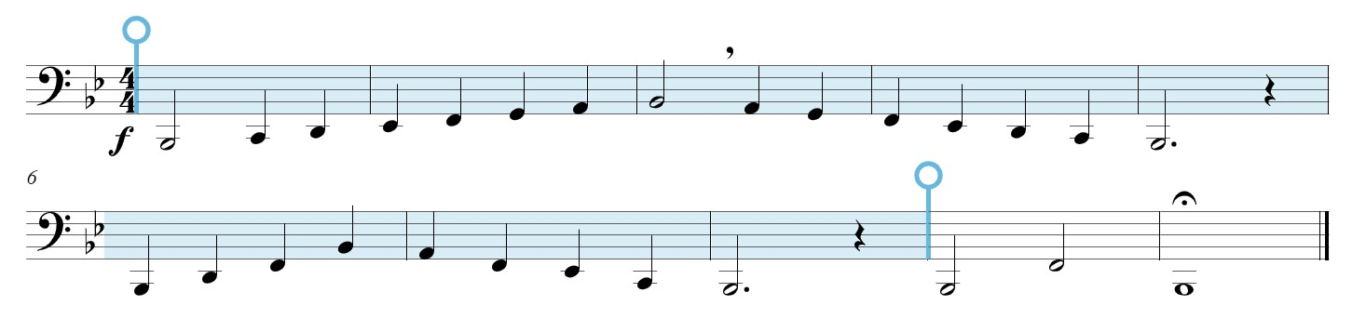

# Scale Etude in B-flat

## FLUTE / OBOE / BELLS

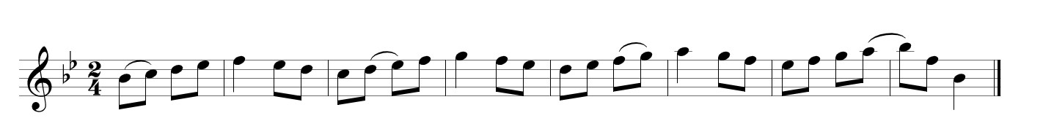

## CLARINET / TRUMPET

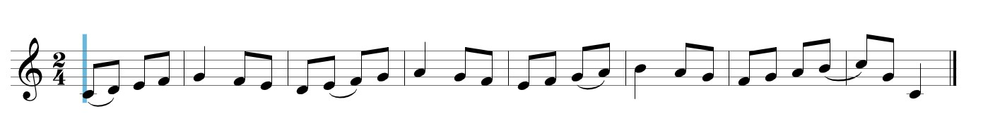

## ALTO SAXOPHONE

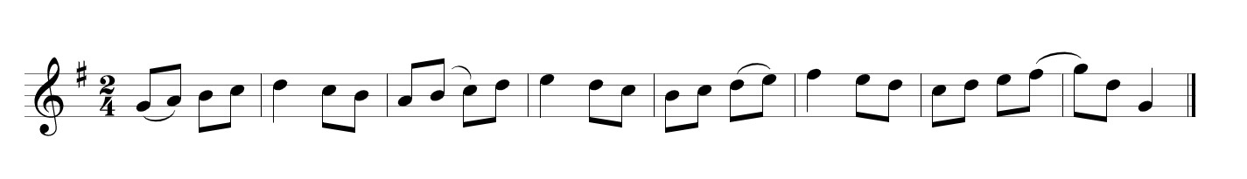

## TENOR SAXOPHONE

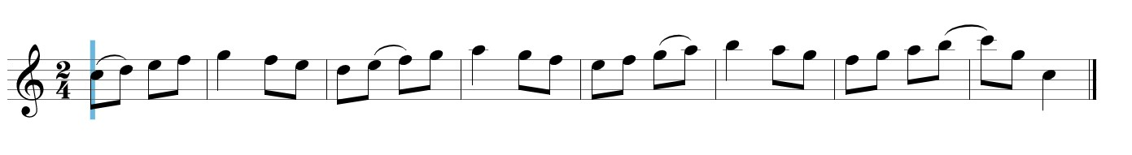

## FRENCH HORN

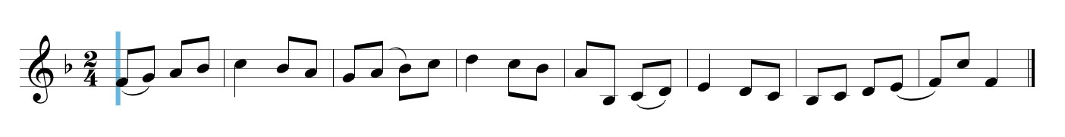

## TROMBONE / BARITONE / EUPHONIUM

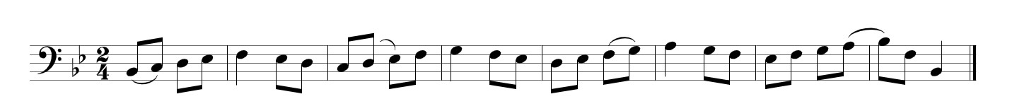

## TUBA

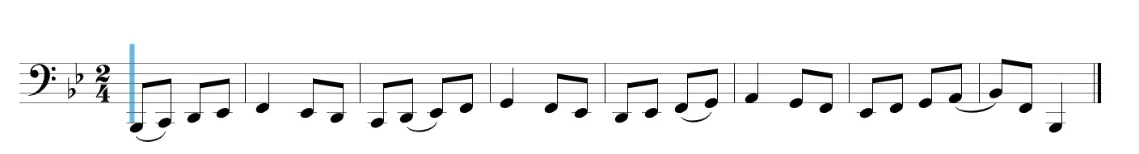

# PERCUSSION REQUIREMENTS

**Students MUST demonstrate the snare drum excerpts below.** If the student also plays mallet percussion, they should demonstrate the **B-flat Concert Scale** and Scale Etude on the previous pages (for bells).

## Snare Drum Excerpt #1 (play between 110 and 120 BPM)

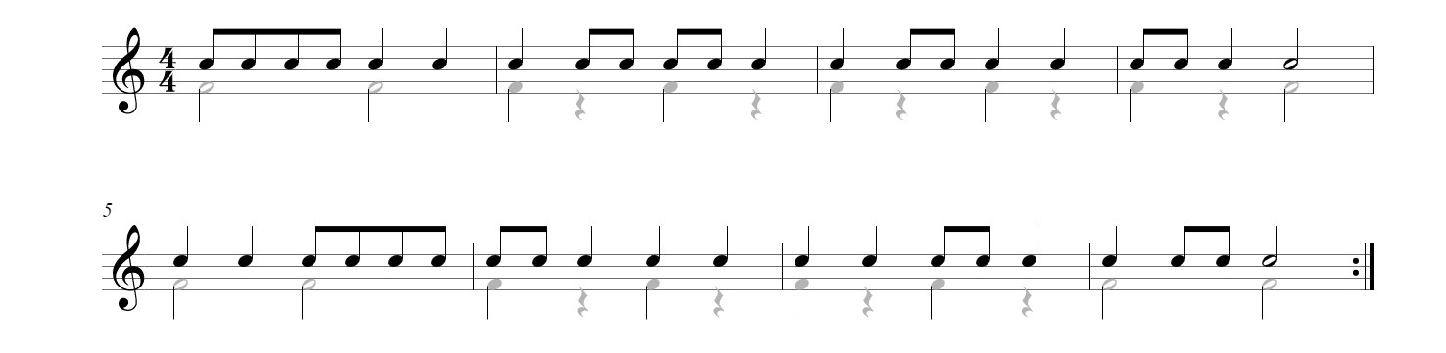

## Snare Drum Excerpt #2 (play between 100 and 120 BPM)